Jennifer Pare
Professor Penhallow
HDF 480 and 481
23 July 2012
Evidence of Goals:

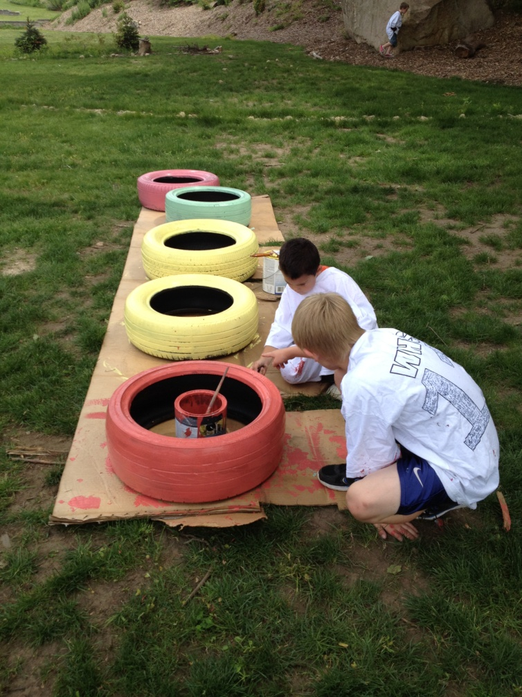
I helped the children to paint these old tires and after they dried we planted flowers in their center and put them around the garden. This was evidence that I helped to build a relationship with the kids because we really got a chance to talk while we painted and I found out that the blonde boy was very athletic outside of the after school program. He plays track and field and he has one in a lot of events. He also asked questions about me and whether I was a volunteer or not. I told him about how I was an intern from URI. It was nice to share a conversation with him and after this moment he trusted me a lot more and now he comes to me sometimes when he’s having an issue with something.

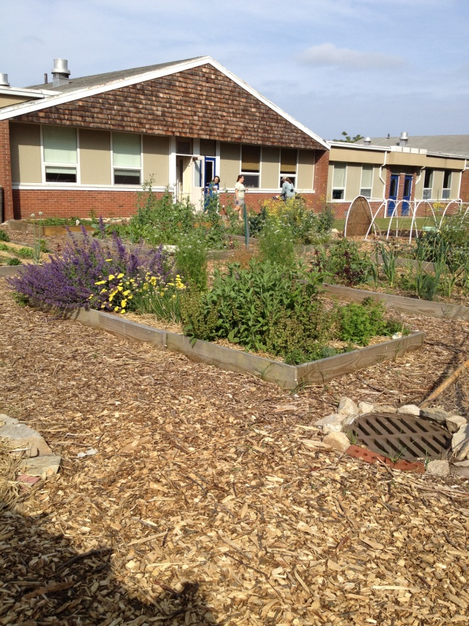
This is the garden that the children created in the back of the community center. It is so beautiful! They have done an awesome job with it over this past summer and have grown so many healthy things! I have helped them with the entire process, from planting, to harvesting to learning to cook the food. This is evidence that I have gained knowledge about how they are learning about more holistic ways to eat at home. Every week they take home the recipe of whatever they made that week so that their parents can try it out.
- One day when I was leading the kids down the hallway to go outside a few of the children were not being respectful and were using loud voices in the hallway which is one of our rules. So I stopped the line and I told them that they needed to be respectful and quiet in the hallway. I moved a couple of kids around because I knew which ones were good next to each other and which ones were not. After that they remained quiet the whole way to the playground. I told them at the end that they did an excellent job and thanked them for behaving the rest of the way.

